
September 10, 2021
4Sight Contract Admin Documentation

4Sight

Version History

Version | Date | Author/Owner | Description of Change
0.1 | 8/22/2021 | Paige Padmore | Creation of 4Sight Contract Admin Documentation
0.2 | 8/23/2021 | Michele Brody | Reviewed document with feedback
0.3 | 8/27/2021 | Paige Padmore | Addressed feedback
0.4 | 9/3/2021 | Michael Jenkins | Reviewed document with feedback
0.5 | 9/10/2021 | Paige Padmore | Edits to 4Sight Contract Admin Documentation
0.6 | 9/15/2021 | Bethany Thompson | Reviewed documentation, added alt text to all images
1.0 | 9/17/2021 | Paige Padmore | Edits to document

Table of Contents
1. Overview 7
1.1 Purpose 7
1.2 Defining Admins 7
1.3 Layout 7
2. Contract Admin Responsibilities 8
2.1 Creating New Users 8
2.2 Assigning Roles to Users 9
2.3 Bulk Importing Funding Data 10
2.4 Bulk Importing Position Data 11
2.5 Deactivate Users 12
3. Admin Module 12
3.1 Contract Settings 12
3.1.1 Labor Rates 13
3.1.2.1 Custom Landing Page 13
3.1.2.2 Support 13
3.1.3 Positions 13
3.1.3.1 Companies 13
3.1.3.1.1 Employee Companies 14
3.1.3.1.2 Pay Companies 14
3.1.3.1.3 Other 14
3.1.3.2 Labor 14
3.1.3.2.1 Positions Funded by 14
3.1.3.2.2 Ranks 14
3.1.3.2.3 Shifts 14
3.1.3.2.4 Systems 14
3.1.3.2.5 Term Reason 14
3.1.3.2.6 Union Codes 14
3.1.3.2.7 WD Labor Codes 15
3.1.3.3 Locations 15
3.1.3.3.1 Departments 15
3.1.3.3.2 Locations 15
3.1.3.3.3 Sub-Department 15
3.1.3.3.4 Sites 15
3.1.3.3.5 Supporting Sites 15
3.1.3.4 Recruiting 16
3.1.3.4.1 Hire Types 16
3.1.3.4.5 Interview Statuses 16
3.1.3.4.6 Recruitment Status 16
3.1.3.4.7 Suffix 16
3.1.4 Quality 16
3.1.4.1 Inspection Finding Corrective Action 16
3.1.4.2 Findings Process 17
3.1.4.3 Findings SubProcess 17
3.1.4.4 Inspection Type 17
3.1.4.5 Inspection Rating 17
3.1.4.6 Inspection Finding Root Cause 17
3.1.4.7 Inspection Finding Preventive Action 17
3.1.4.8 Responsible Organization 17
3.1.4.9 Customer Organization 17
3.1.4.10 Criticality 17
3.1.4.11 Method of Verification 18
3.1.4.12 Objective Evidence 18
3.1.5 Training 18
3.1.5.1 Category 18
3.1.5.2 Class Scores 18
3.1.5.3 Contact Info 18
3.1.5.4 Exempt 18
3.1.5.5 Frequency 19
3.1.5.6 Types 19
3.2 Global System Settings 19
3.2.1 Risk 19
3.2.1.1 Assessment Probability 19
3.2.1.2 Assessment Impact 19
3.2.1.3 Risk Assessment Type 19
3.3 Security 19
3.3.1 Imports 19
3.3.2 Merge Employee 20
3.3.3 Report Proxy Audit 20
3.3.4 Report User Hits 20
3.3.5 Security User Hits 21
3.3.6 User Sessions 21
3.3.7 Users 21
4. Additional Admin Pages 22
4.1 Asset Module 22
4.1.1 Asset Import 22
4.1.2 Sites Admin 22
4.1.3 Asset Drop Down Admin 23
4.1.4 Other Name Admin 24
4.1.5 Asset Manage Approvers 24
4.2 Positions Module 25
4.2.1 Supervisor Assignment 25
4.2.2 Position Import 26
4.3 Purchase Request Module 26
4.3.1 Setup 26
4.3.2 Contract Funding 27
4.3.3 PO Checkbook Funding 27
4.3.4 Drop Shipments 28
4.3.5 Manage CLIN/SLIN Expiration Notification Settings 29
4.4 Quality Module 29
4.4.1 Focus Area 29
4.4.2 Standard Masters 30
4.4.3 PWS Masters 30
4.4.4 PWS Requirements 31
4.4.5 Equipment Listing 31
4.4.6 Area Listing 32
4.5 Risk Module 33
4.5.1 Risk Admin Impact 33
4.5.2 Risk Admin Probability 33
4.6 ROM Module 34
4.6.1 Setup 34
4.6.2 Manage Sites 34
4.6.3 Manage Labor Categories 35
4.6.4 Manage CTN Drop-Downs 35
4.6.5 Manage Subcontractors 35
4.6.6 Manage Income Table 36
4.6.7 Manage Section Templates 36
4.7 Survey Module 37
4.7.1 Manage Sites 37
4.8 Tasking Module 38
4.8.1 Manage Drop-Downs 38
4.8.2 Manage Workflow Default Assignments 38
4.9 Training Module 39
4.9.1 Course Admin 39
4.9.1.1 Active Courses 39
4.9.1.2 Inactive Courses 39
4.9.1.3 All Courses 39
4.9.1.4 Assign Courses By 39
4.9.2 Class Admin 41
4.9.2.1 Active Classes 41
4.9.2.2 Closed Classes (For Last 12 Months) 42
4.9.2.3 Archive Classes 42
4.10 Transportation Module 43
4.10.1 Settings 43
4.10.2 Manage Drop-Downs 43
4.10.3 Manage Sites 44
4.10.4 Manage Receiving POCs 44
4.10.5 Manage Shipping POCs 45
4.10.6 Manage Modes of Shipment 45
4.10.7 Manage RMA Types 46
4.10.8 Manage Approvers 47
4.11 Travel Module 48
4.11.1 Admin Setup 48
4.11.2 Manage Drop-Downs 48
5. Additional Information 49
5.1 General Navigation 49
5.2 Escalating to 4Sight Admins 51
5.3 Requesting Admin Access 51
Acronyms/Terms 52

Contract Admin Documentation

Overview
The following information provides steps on unique capabilities that admins can execute on 4Sight. As well, it describes the Admin site within the 4Sight Instance and what each section can do.

1.1 Purpose
The purpose of this document is to be the one source of information for contract admin users to understand admin capabilities in 4Sight and how to navigate through specific modules and pages.

1.2 Defining Admins
A contract administrator, “contract admin” or “admin” user represents users that have rights to editing, adding, or removing specific information or capabilities in 4Sight for their designated program(s). Admins have other specific capabilities that allow for bulk importing new information or changes to 4Sight in order to host data needed for their program. Admins can have access to the Admin module and admin pages within certain modules depending on contractual needs. Depending on the program and specific roles, admin users may not be able to access some of the related pages in the Admin module. Different modules and pages require different contract admin rights and capabilities, which will make some views inaccessible based on the roles a contract admin has.

1.3 Layout
The layout of this document includes:
- Contract Admin Responsibilities – Includes the typical tasks that contract admins are expected to execute and how to execute such tasks.
- Admin Module Pages and Views – Defines the pages and views within the Admin module, how to navigate such pages, and what a contract admin can do in these instances.
- Specific Module Admin Pages – Describes the capabilities of admins within different modules if granted; these are for the core modules available for admins to have additional capabilities.
- Escalation and Additional Support – Provides information on when to escalate to a 4Sight admin (different from contract admin) and who to contact for support outside of the confines of contract admin privileges.

2. Contract Admin Responsibilities
4Sight Contract Admins are responsible for the following:
- Manage user accounts
- Manage drop-down values in the admin module and other modules
- Import data necessary for the program and select modules
- General administration of modules
- Assigning default users to workflow steps
- Setting up sites/locations within modules

2.1 Creating New Users
- Create One New User
  - Go to the Users page under the Security section of the Admin module.
  - Select in the righthand upper corner of the page.
  - All fields with a red asterisk represent required fields. The following steps are needed to execute the process correctly.
    - The User Name field must be the Employee ID of the user.
    - Select if the user is Internal (GDIT) or External.
    - Employee Number should be the user’s Employee ID.
    - Contract of Record represents the contract the user should have access to.
    - Employee Company should be the company the employee works under (GDIT, sub-contractor, etc.).
    - Password should be left blank if a system generated password is preferred.
    - Status should be made Active by checking off the box next to Active.
    - Provide the First Name, Last Name, and email address (directly associated with the contract, such as the GDIT email address).
    - Add in any other additional information necessary.
    - If desired, assign contracts, roles and document library roles by selecting the available contracts, roles, and/or document library roles and moving them under the assigned list by using the “>>” arrows. To remove role(s), select the role(s) under the Assigned Contracts, Assigned Roles, and/or Assigned Document Library Roles and use the “<<” arrows to move them back under the available lists.
    - Select Save in the upper righthand corner.
- Bulk Create/Import New Users
  - Click here to go to this view and to begin creating new users/bulk importing users.
  - Follow the below instructions as seen in the link:
- This upload process is for creating new users only.
- All fields marked with a red * must be entered for the user to be uploaded.
- When usernames are entered in your upload file, they are treated as a suggestion. If the desired username of JDOE exists, a number will be appended to the end of the username until it is unique within the system.
- If no username is entered in your upload file, then a username will be generated using a combination of First Name + Last Name. Example: JANE DOE will become JDOE and a number suffix will be applied for uniqueness.
- Email address is required to be unique within the system on a global scale.
- Employee Numbers are required and are to be unique within the system for the contract the users are being imported to.
- The template file is an Excel document. This file should be saved as a .CSV file and then be used to upload.
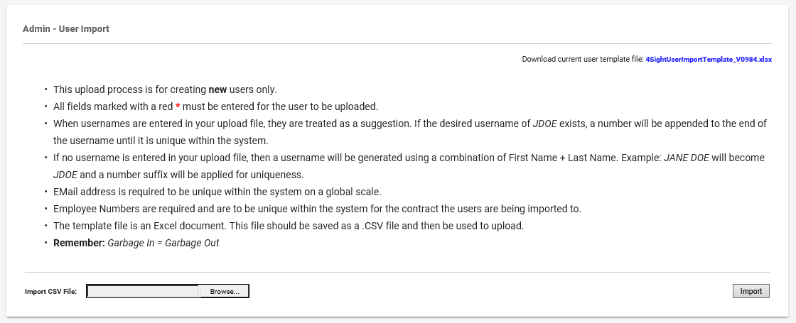

Assigning Roles to Users
Admins can assign new users roles to access different modules and receive different capabilities. These roles along with their rights can be found in the Security Roles Matrix. Admins can assign roles to users by executing the following:
- To add roles to users you need to go to:
  - Admin > Security > Users
- Select the user that you want to add roles to.
- Select the roles under Available Roles and move the roles from left to the right under the Assigned Roles.
  - This applies to the Available/Assigned Document Library Roles as well.
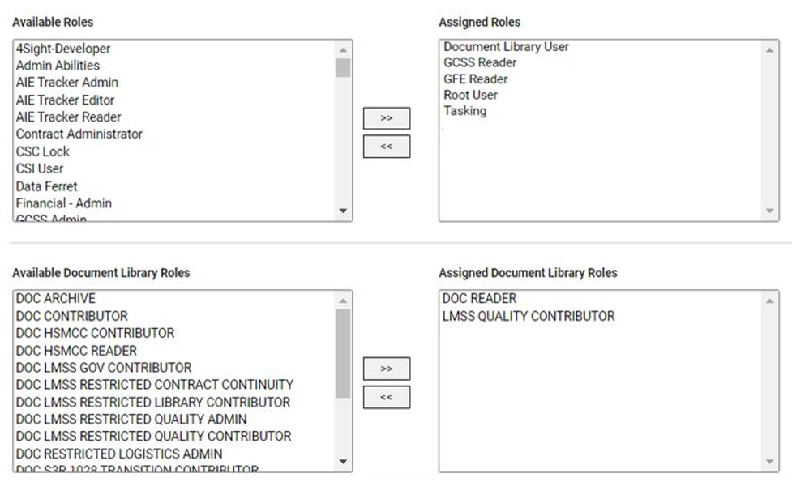

Bulk Importing Funding Data
Admins can import funding data by executing the following tasks:
- Click here to go to this view and to begin bulk importing funding information.
- Follow the below instructions as seen in the link:
- Select a module to associate the funding import with. For example, if an import is associated with the Purchase Request module, CTNs from that import will be available only in the Purchase Request module.
- CTN, CLIN, and Identifier are required columns.
- If a row fails to contain any one of the required columns, that row will be skipped and reported as an error.
- This import uniquely identifies entries by a combination of CTN, CLIN, Identifier, and Account Number. It is not necessary to have an Account Number so long as uniqueness is maintained among the required columns.
- If an entry is found in the database matching the above values, that entry will be updated with the values from the import. If an entry is not found, a new entry will be created.
- The funding import takes into account cutoff dates for the purposes of calculating a checkbook balance. See the dates below. The Final Active LOA Balance is considered to include funding for PRs and TARs approved before their respective cutoff dates.
  - Cutoffs are determined beginning from the closest previous Thursday. (If today is Thursday, then today)
  - PR with credit card purchase type: Previous Saturday at midnight
  - All other PRs: Previous Wednesday at midnight
  - Travel: Previous Tuesday at 5 pm

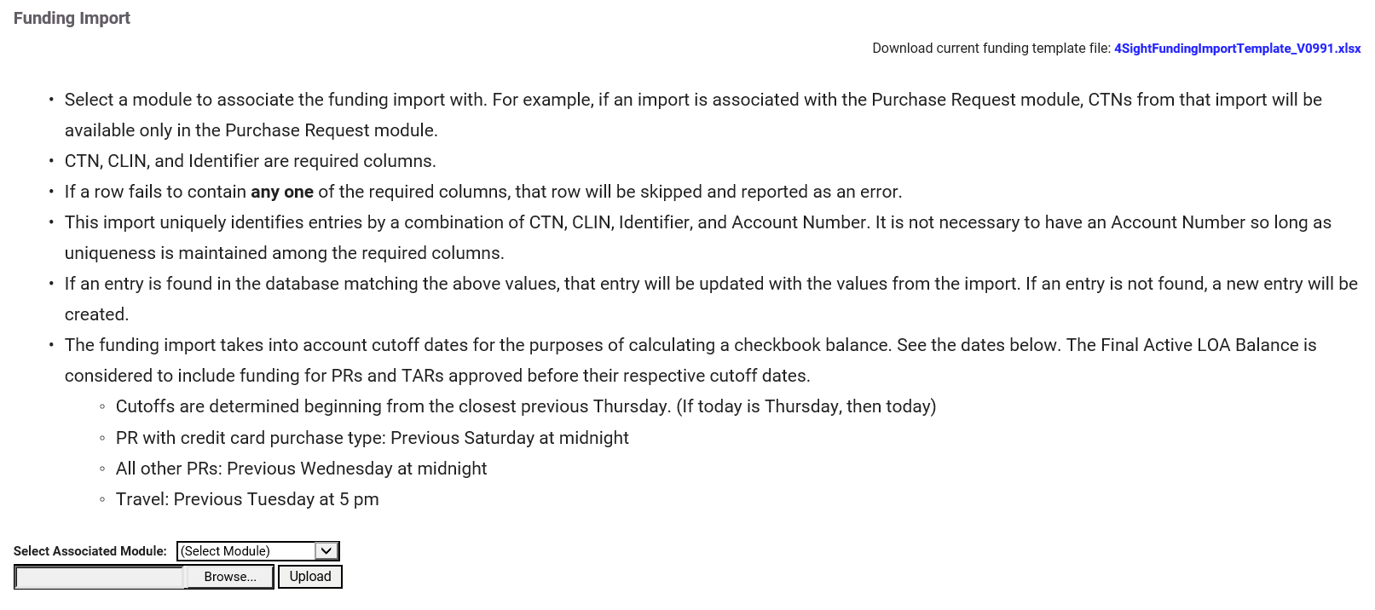

Bulk Importing Position Data
Admins can import new positions into 4Sight by executing the following tasks:
- Click here to go to this view and to begin bulk importing new positions.
- Follow the below instructions as seen in the link:
- This upload process is for creating new positions only.
- All fields marked with a red * must be entered for the position to be uploaded.
- The template file is an Excel document. This file should be saved as a .CSV file and then be used to upload.

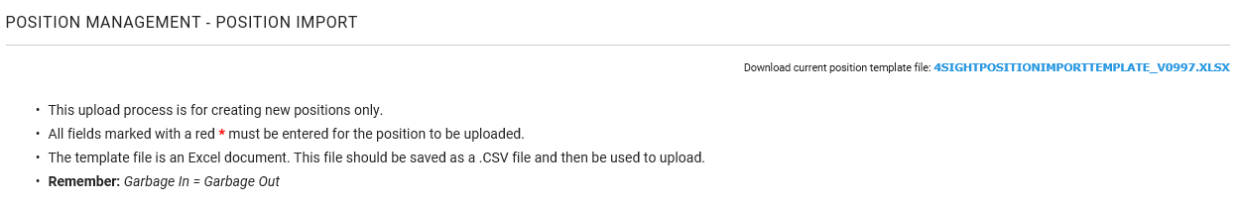

Deactivate Users
Below provides the steps to deactivate a user that should no longer have access to a program’s 4Sight instance or multiple instances.
- Go to the Users page under the Security section of the Admin module.
- Select the user of choice from the table (for advanced search options and general page flipping, go to the General Navigation section of the document for more information).
- Select the name of the user (blue hyperlink).
- Under Status, deselect the Active checkbox.
- 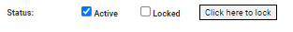
- Select Save to make the changes.
- Verify by going back to the Users page and searching for the user’s name. After finding the name, check to see if the status says “Inactive.”
- To double check, click on Click here to login on the user’s record. The following error message should be shown:
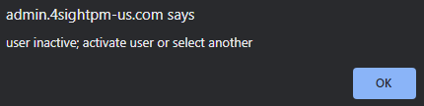

Admin Module
Admin Pages can be found under the Admin module in the dropdown under the user’s name and related program. It is where most admin capabilities are housed in order to add, edit, or remove program information within 4Sight. This section lists capabilities for admin users. Depending on related roles, some may not be available to certain contract admin users.

3.1 Contract Settings
Main dropdown option under Admin module.

3.1.1 Labor Rates
The Labor Rates page is where the rates for labor are entered for the ROM and travel modules. The fee, rate, and hour information contains descriptions on each of the unique lines and can be saved for the modules. See the screenshot below labeled for better understanding the values and descriptions. Select Save in the righthand upper corner to save any changes made: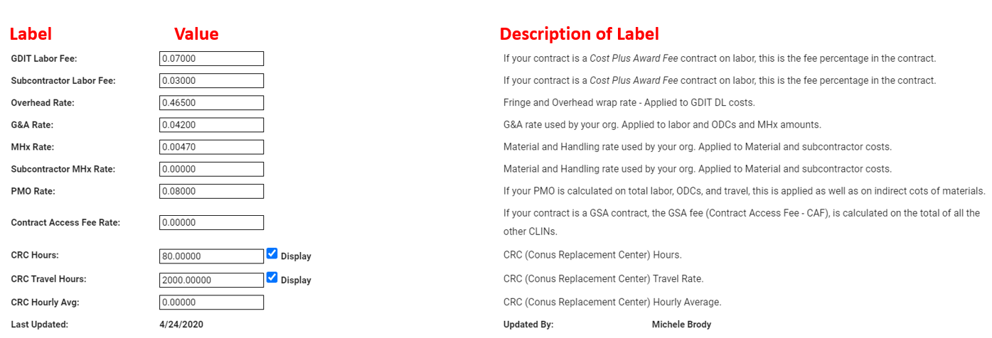3.1.2 Misc
Section under Contract Settings with more dropdowns.

3.1.2.1 Custom Landing Page
This dropdown provides the ability to provide an image in the homepage image space. In the instructions, it defines on the page the sizing, the formatting, the darkness to support the contrast, and how to upload the landing page banner file. The capabilities can be found below in the screenshot: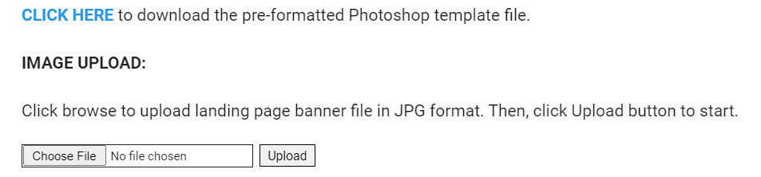

3.1.2.2 Support
This dropdown page provides the support actions and if they are currently active. It gives you the ability to edit and add new rows to the support actions. See the General Navigation section for more details on how to navigate the page.

3.1.3 Positions
Section under Contract Settings with more dropdowns.

3.1.3.1 Companies
Section under Positions with more dropdowns.

3.1.3.1.1 Employee Companies
This page represents the employee companies that are active under current employees. An admin can edit these details or add new details for new companies on this page. See the General Navigation section for more details on how to navigate the page.

3.1.3.1.2 Pay Companies
These represent the pay companies that are active under current employees. An admin can edit these details or add new details for new companies on this page. See the General Navigation section for more details on how to navigate the page.

3.1.3.1.3 Other
These represent other companies that are active under current employees. An admin can edit these details or add new details for new companies on this page. See the General Navigation section for more details on how to navigate the page.

3.1.3.2 Labor
Section under Positions with more dropdowns.

3.1.3.2.1 Positions Funded by
This shows the positions funded by information that are active under labor. An admin can edit these details or add new position funding on this page. See the General Navigation section for more details on how to navigate the page.

3.1.3.2.2 Ranks
These represent ranks that are active under labor. An admin can edit these details or add new ranks on this page. See the General Navigation section for more details on how to navigate the page.
        - Shifts
These represent shifts that are active under labor. An admin can edit these details or add new shifts on this page. See the General Navigation section for more details on how to navigate the page.
        - Systems
These represent systems that are active under labor. An admin can edit these details or add new systems on this page. See the General Navigation section for more details on how to navigate the page.
        - Term Reason
This page defines categories, statuses, and voluntary attrition of term reasons. See the General Navigation section for more details on how to navigate the page.
        - Union Codes
These represent union codes that are active under labor. An admin can edit these details or add new union codes on this page. See the General Navigation section for more details on how to navigate the page.
        - WD Labor Codes
These represent labor codes that are active under labor. An admin can edit these details or add new labor codes on this page. See the General Navigation section for more details on how to navigate the page.
      - Locations
Section under Positions with more dropdowns.

3.1.3.3.1 Departments
This shows the departments that are active under locations. An admin can edit these details or add new departments on this page. See the General Navigation section for more details on how to navigate the page.
        - Locations
This shows the locations that are active currently. An admin can edit these details or add new locations on this page. See the General Navigation section for more details on how to navigate the page.
        - Sub-Department
This shows the sub-departments that are active under locations. An admin can edit these details or add new sub-departments on this page. See the General Navigation section for more details on how to navigate the page.

3.1.3.3.4 Sites
This provides the sites including the associated countries, statuses, AFSB information, and SWA statuses. An admin can edit these details, search, or add new sites on this page. See the General Navigation section for more details on how to navigate the page.
        - Supporting Sites
This provides the supporting sites including the associated countries and statuses. An admin can edit these details, search, or add new supporting sites on this page. See the General Navigation section for more details on how to navigate the page for editing details and searching for records. Selecting Add New will show the below prompt. Fill out all information to the best of your ability, including the required field (red asterisks) and select Save when done:
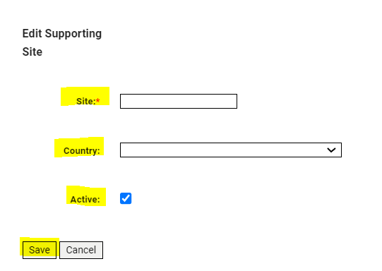
      - Recruiting
Section under Positions with more dropdowns.

3.1.3.4.1 Hire Types
This shows the hire types that are active under recruiting. An admin can edit these details or add new hire types on this page. See the General Navigation section for more details on how to navigate the page.
        - Interview Statuses
This shows the interview statuses that are active under recruiting. An admin can edit these details or add new interview statuses on this page. See the General Navigation section for more details on how to navigate the page.
        - Recruitment Status
This shows the recruitment statuses that are active under recruiting. An admin can edit these details or add new recruitment statuses on this page. See the General Navigation section for more details on how to navigate the page.
        - Suffix
This shows the suffixes that are active under recruiting. An admin can edit these details or add new suffixes on this page. See the General Navigation section for more details on how to navigate the page.
    - Quality
Section under Contract Settings with more dropdowns.

3.1.4.1 Inspection Finding Corrective Action
This shows the corrective actions that are active under quality. An admin can edit these details or add new corrective actions on this page. See the General Navigation section for more details on how to navigate the page.
      - Findings Process
The Findings Process page is determined by the Quality Leader and/or Quality ISO Professionals within the program, defining the type of inspections and audits for the process. See the General Navigation section for more details on how to navigate the page.

3.1.4.3 Findings SubProcess
The Findings SubProcess page is determined by the Quality Leader and/or Quality ISO Professionals within the program, defining the type of inspections and audits for the subprocess. See the General Navigation section for more details on how to navigate the page.
      - Inspection Type
This shows the inspection types, including their statuses and descriptions, under quality. An admin can edit these details or add new inspection types on this page. See the General Navigation section for more details on how to navigate the page.

3.1.4.5 Inspection Rating
This represents the inspection ratings, including their statuses and descriptions, under quality. An admin can edit these details or add new inspection ratings on this page. See the General Navigation section for more details on how to navigate the page.

3.1.4.6 Inspection Finding Root Cause
This represents the root cause descriptions and statuses under quality. An admin can edit these details or add new root causes on this page. See the General Navigation section for more details on how to navigate the page.

3.1.4.7 Inspection Finding Preventive Action
This represents the prevention action descriptions and statuses under quality. An admin can edit these details or add preventative actions on this page. See the General Navigation section for more details on how to navigate the page.
      - Responsible Organization
This showcases the responsible organizations, including descriptions and active statuses, under quality. Admins can add new or edit details of these descriptions. See the General Navigation section for more details on how to navigate the page.

3.1.4.9 Customer Organization
This showcases the customer organizations, including descriptions and active statuses, under quality. Admins can add new or edit details of these descriptions. See the General Navigation section for more details on how to navigate the page.
      - Criticality
This provides the criticality of quality with descriptions and active statuses. Admins can add new or edit details of these descriptions. See the General Navigation section for more details on how to navigate the page.
      - Method of Verification
This provides methods of verification with descriptions and active statuses. Admins can add new or edit details of these descriptions. See the General Navigation section for more details on how to navigate the page.
      - Objective Evidence
This provides objective evidence entries with descriptions and active statuses. Admins can add new or edit details of these descriptions. See the General Navigation section for more details on how to navigate the page.
    - Training
Section under Contract Settings with more dropdowns.
      - Category
This shows the training categories that are active. Admins can add new or edit details of these categories. See the General Navigation section for more details on how to navigate the page.
      - Class Scores
This represents the training class scores that are active. Admins can add new or edit details of these scores. See the General Navigation section for more details on how to navigate the page.
      - Contact Info
This page is where admins can add in contact information for training sessions to save contact information line by line. To add contract line information, type in the desired line item and select Save in the righthand upper corner. To change the information in a line item, simply remove the current information and add new information to save over the old data.
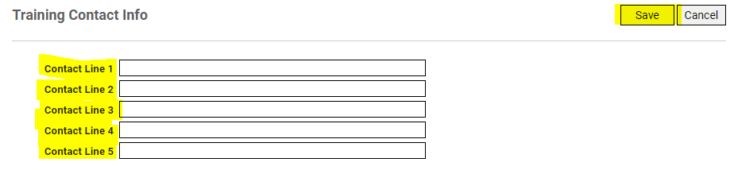
      - Exempt
This represents the training exempt entries that are active. Admins can Add New or Edit Details of these exemptions. See the General Navigation section for more details on how to navigate the page.
      - Frequency
This represents the training frequency descriptions that are active, including descriptions, number of days and months. Admins can add new or edit details of these frequencies. See the General Navigation section for more details on how to navigate the page.
      - Types
This represents the training type entries that are active. Admins can add new or edit details of these training types. See the General Navigation section for more details on how to navigate the page.

Global System Settings
Main dropdown option under Admin module.
    - Risk
Section under Global System Settings with more dropdowns.
      - Assessment Probability
This defines the probability of risks with descriptions and active statuses. Admins can edit details or add new probability descriptions. See the General Navigation section for more details on how to navigate the page.
      - Assessment Impact
This defines the rate of impact with descriptions and active statuses. Admins can edit details or add new impact descriptions. See the General Navigation section for more details on how to navigate the page.
      - Risk Assessment Type
This defines the different types of risks associated with a program and if they are active. Admins can edit details or add new risk descriptions. See the General Navigation section for more details on how to navigate the page.

Security
Main dropdown option under Admin module.
    - Imports
This page provides a place where admins can bulk import information such as funding and new users.
    - Merge Employee
This page gives the admin user to capability of merging old and new employee numbers. This helps with consolidating an employee under one number. To execute this properly, users should add the old employee number ID in the Old Employee # field and the new employee number ID in the New Employee # field and select Merge Record Now to execute the action.
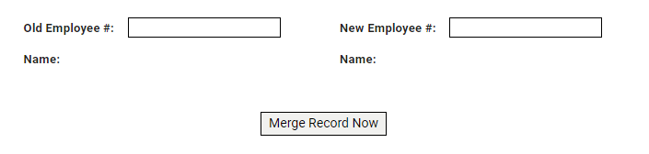
    - Report Proxy Audit
This page represents the ability to view user session logins with the ability to print, save and change filters. Select values from the filters provided according to what’s needed. Leave all of the default options to view a very general report. Set specific filters to narrow down the result. Once the filter selections have been made, click View Report in the righthand upper corner. See the screenshot below to see how this information looks:
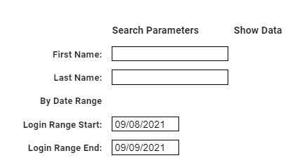
    - Report User Hits
This provides the ability to search for user session hits by name and date range. Select values from the filters provided according to what’s needed. Leave all of the default options to view a very general report. Set specific filters to narrow down the result. Once the filter selections have been made, click View Report in the righthand upper corner. See the screenshot below to see how this information looks:
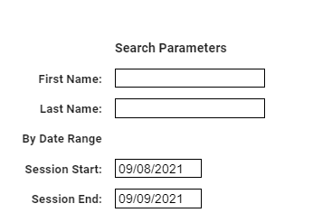
    - Security User Hits
This page defines the last 1000 hits the user had within the 4Sight application. This will provide the name of the user and their ID along with the pages and the time in which they were visited. See the General Navigation section for more details on how to navigate the page, specifically the Show Search/Advanced Search.
    - User Sessions
This page defines the sessions of each user within a contract including their session start and if they are considered a system admin. In this view, it gives you the ability to end sessions as well. Select End Session next to the individual record desired to end the session of the person. See the below screenshot to view how this would be executed in the last column on the right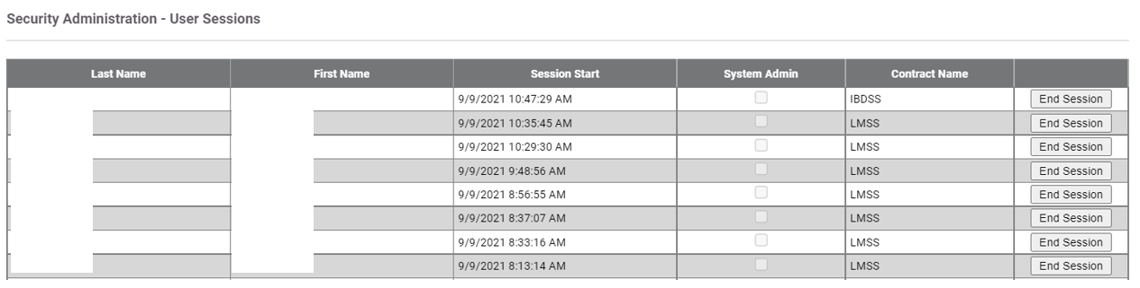
    - Users
This provides security admin users with the names, usernames, statuses, emails, and more. This provides a one-stop shop for admins to add new users, email the user list, bulk assign roles, and bulk add users. To view individual record details, select the name of the record on the leftmost column of the table to view the information. To login as another user to view their view, select the Login Account hyperlink in the rightmost column of the table.
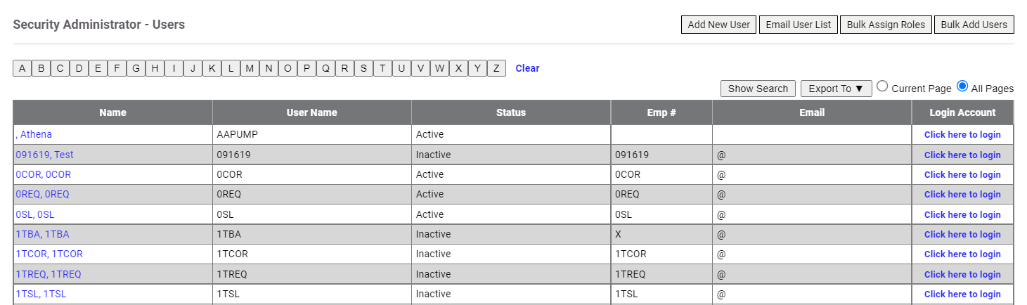
For instructions on Add New User and Bulk Add Users, visit the Create New Users section. For instructions on Bulk Assign Users, visit the Assign Roles to Users section. For more information on Show Search and Export To functions, go the to the General Navigation section.

Additional Admin Pages
Additional Admin Pages can be found under modules outside of the Admin module. These include the following:

Asset Module
All admin capabilities under this module can be found under the Asset Admin dropdown.
    - Asset Import
This location is where assets can be imported along with instructions on how to upload new assets. It provides a template file to be imported for 4Sight.
        - Instructions:
- All fields marked with a red * must be entered for the asset to be uploaded.
- The AssetNo field is not required and if the cell is left empty, an autogenerated number will be created upon import.
  - If you enter an AssetNo, we currently do not check for uniqueness within your contract.
- Within the Asset module, quantities of assets are always 1 as these assets are not considered "consumable". We will override quantities to be 1.
- Lookup columns that have a name starting with LU_ or SYS_ will be checked for values that already exist. If they exist, the asset will be associated to that value, otherwise a new entry will be created.
- The template file is an Excel document. This file should be saved as a .CSV file and then be used to upload.
- Import the file in Choose File based on the template provided.
    - Sites Admin
This page defines the sites that are currently active along with who they were last updated by and when they were last updated. An admin can add site names along with selecting site names to update them through selecting the name by searching for the entry.
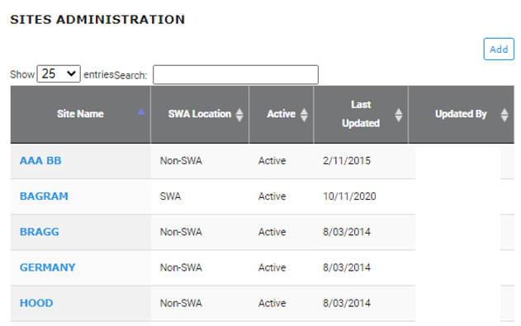
View for adding a new site can be seen below. Users can select Save to make changes. 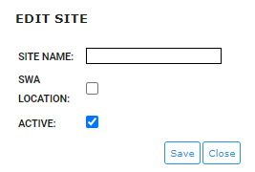
    - Asset Drop Down Admin
This page provides a place to setup drop-down values. Admins can select the blue boxes provided to view descriptions and active statuses related to the selection. To add new records associated with the blue box selected admins can select the Add button on the left-hand side of the page. To edit values, admins can select Edit next to the desired line-item.
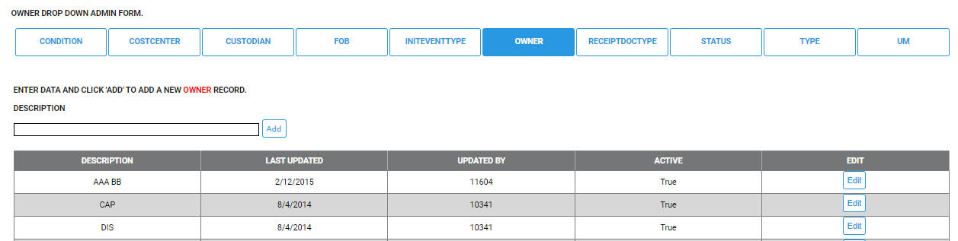
    - Other Name Admin
This enables admins to add custom labels for the contract within the asset records. Individuals can do so by filling out the custom labels of their choice and selecting Save.
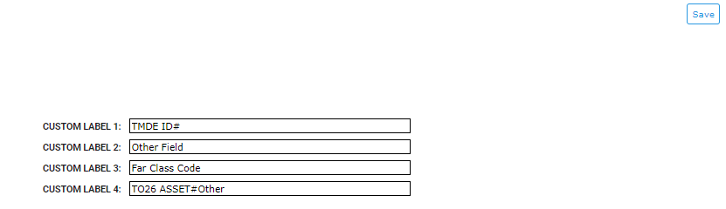
    - Asset Manage Approvers
Admins can set default approvers for asset by selecting a site and adding individuals to GFE admin, editor, site lead, PMO, and/or PMC. In order to see these options, admins must first Select a Site. Then, admins can select specific individuals by choosing Add Items or remove users by selecting Remove Items.
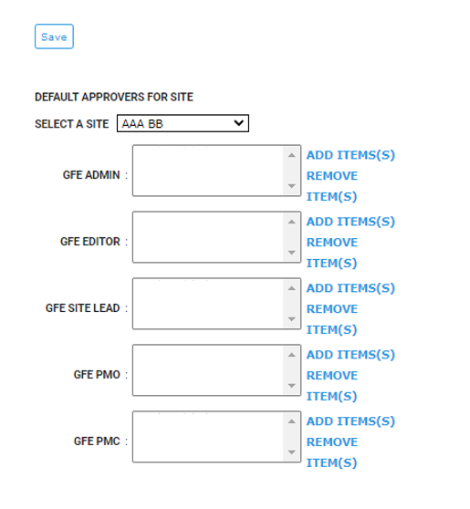

Positions Module
All admin capabilities under this module can be found under the Positions dropdown. There are specific capabilities in the dropdown that are not available for regular users.
    - Supervisor Assignment
This shows the supervisor search page, with the ability to export and search for more supervisor information (see General Navigation section for more information on how to navigate the table). By selecting Add Supervisor in the righthand upper corner, admins can add supervisors and assign individuals to the supervisor. To add a Supervisor, select the ellipsis button next to the field and select the appropriate Supervisor (see General Navigation section for more information on Advanced Search). From there you can assign individuals to supervisors under Assigned People. Select a user by scrolling or the Search function under the Unassigned People section, select the user(s), and move them over to the Assigned People section using the “>>” arrows. To unassign people, select the user(s) under Assigned People and move them over to the Unassigned People using the “<<” arrows. Select Save to save the information.
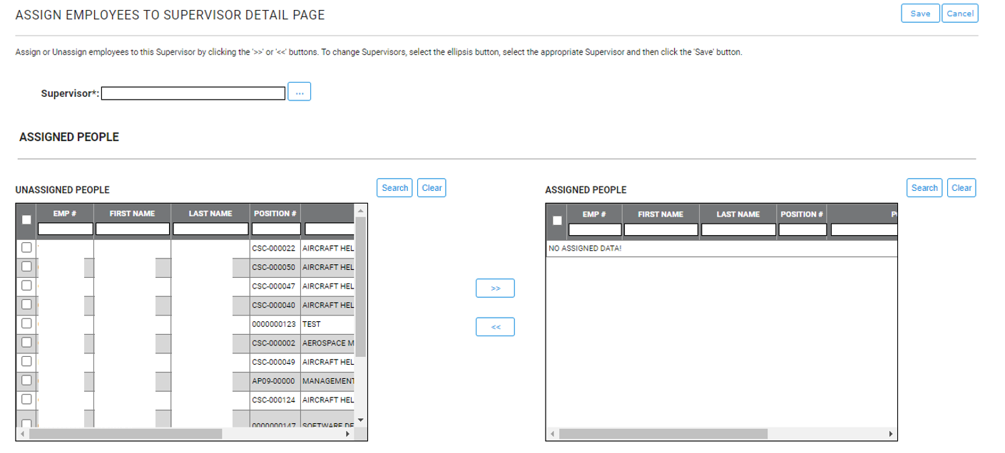
    - Position Import
This page provides the ability for admins to bulk import positions. See the Bulk Importing Position Data section for more information.

Purchase Request Module
All admin capabilities under this module can be found under the Admin dropdown.
    - Setup
This gives admins the ability to look at contract details and add in new task orders to manage. Admins can create new task orders by selecting Create New Task Order in the left-hand side of the page. They can also edit task orders by selecting Manage next to the line-items on the left-hand side of the page.
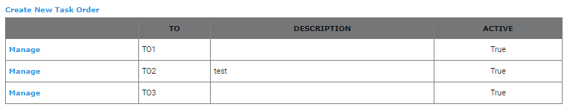Additionally, admins can edit contract lookups and rates, including selecting the dropdowns, selecting Edit to edit specific items, selecting Add Item(s)/Remove Item(s) for buyers, and editing contract rates by selecting Save Contract Rates.
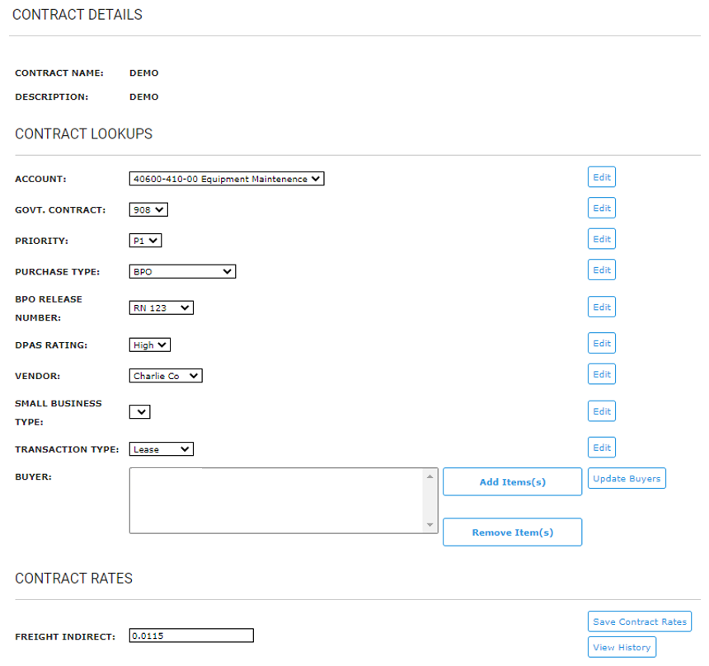
    - Contract Funding
This provides a view of the funding available in the current module. Funding can be imported in bulk through the Admin module. On this page, admins can Search for funding line-items and specify the items needed.
Admins can also edit line-items by selecting Edit next to the desired item.
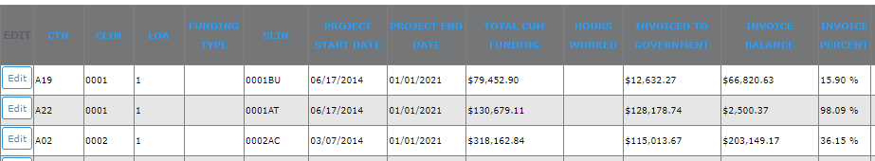
    - PO Checkbook Funding
This location is where PO checkbook funding is stored, with details regarding purchase type, unique numbers, vendors, balances, and active statuses. Admins can add new records by selecting Add in the upper left-hand corner, and filling out the below information in the screenshot:
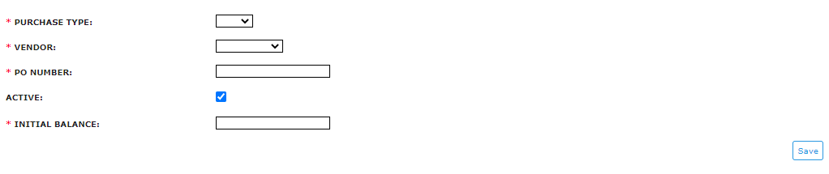
Funding can be imported by selecting Import Funding in the right-hand upper corner of the page. For other functionality within the page, visit the General Navigation section for more information.
    - Drop Shipments
This provides drop shipment site and drop shipment POC information, with the ability to add, edit, and assign users to shipments. Admins can add sites by selecting Add on the left-hand upper corner under View POCs. They can also search for sites with the Search function below the Add function, as well as edit line items by selecting Edit next to the desired record.
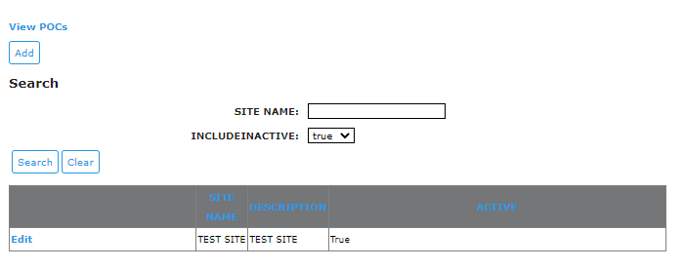
Admins can also assign users by selecting a user under the Unassigned Users list and using the “>>” blue arrows to move the names over to the Assigned POCs list. To remove POCs from the Assigned POCs list, admins would perform the opposite action.
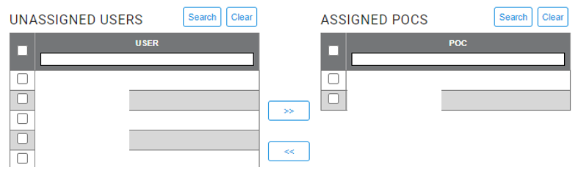
    - Manage CLIN/SLIN Expiration Notification Settings
This page represents notification settings for CLIN/SLIN expirations statuses if they are enabled. If the Enable Notifications button is selected, admins can set the Begin Notifying Days Before field to the days in which they would like to be notified before expiration.
This page also gives admins the ability to edit roles, remove roles by selecting the line item and choosing Remove Roles on the right-hand side of the page. The page also gives admins the ability to add roles by selecting Add Roles at the bottom of the page with a dropdown to select certain roles.
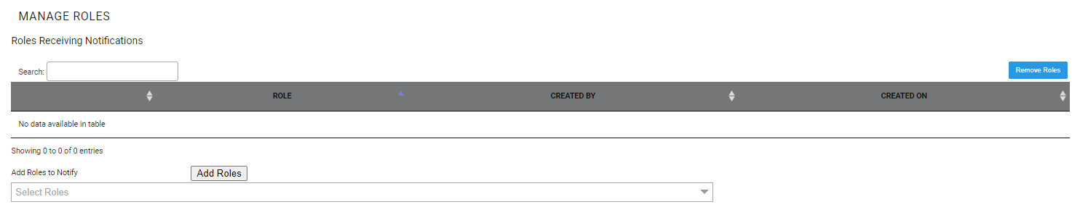

Quality Module
All admin capabilities under this module can be found under the Setup dropdown.
    - Focus Area
This provides the focus areas of quality, including their purpose, primary leader, and if membership is required. Admins can add additional focus areas by clicking Add Focus Area in the righthand upper corner of the page. Each section of the form contains descriptions on what should be filled in for the record. Select Save to save the information.
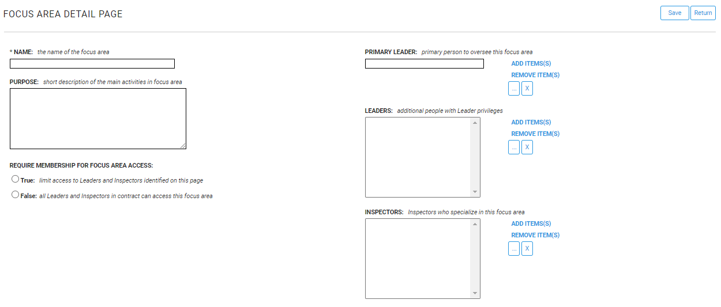
See the General Navigation section for more details on how to navigate the rest of the table on the main page.
    - Standard Masters
This page shows masters associated with specific focus areas. New masters can be added by selecting Add Master in the righthand upper corner of the page. From there, provide the required fields (fields with asterisks) and select Save once filled in.
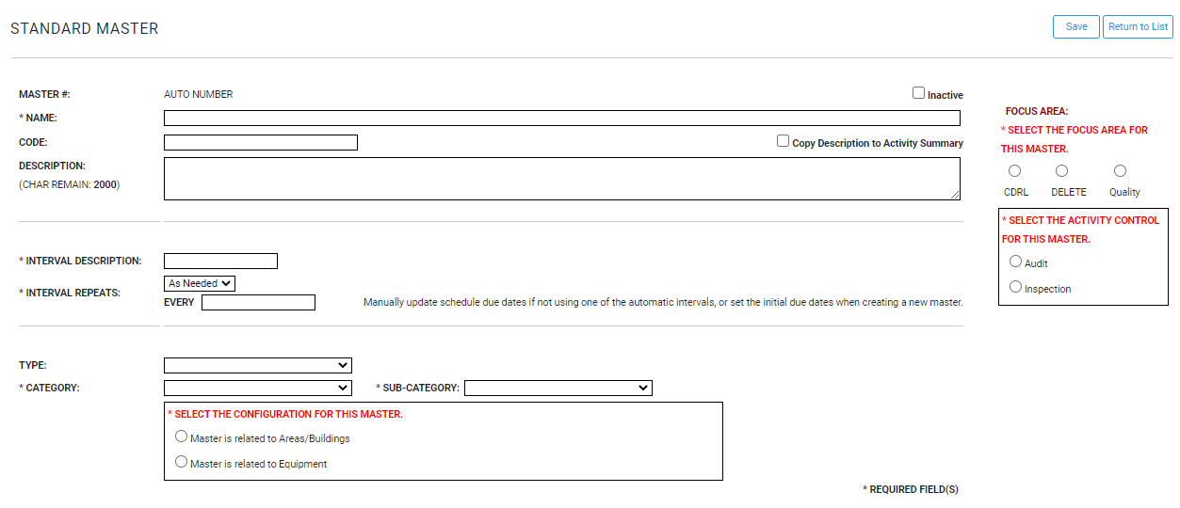
See the General Navigation section for more details on how to navigate the rest of the table on the main page. Additionally, by selecting the FOCUS AREA in blue at the top middle of the page, you can change the focus area to another name.
    - PWS Masters
This page lists the PWS masters associated with specific focus areas. New PWS masters can be added by selecting Add Master in the righthand upper corner of the page. From there, provide the required fields (fields with asterisks) and select Save once filled in.
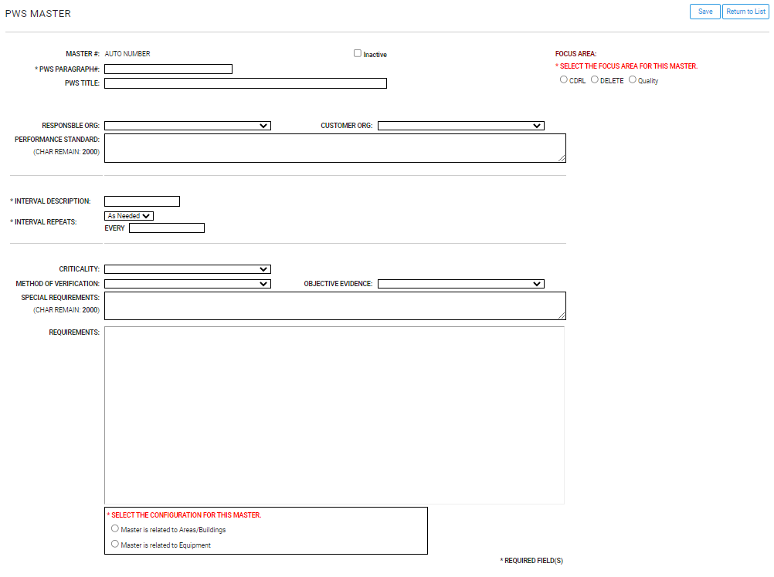
See the General Navigation section for more details on how to navigate the rest of the table on the main page. Results may also be searched or exported. Additionally, by selecting the FOCUS AREA in blue at the top middle of the page, you can change the focus area to another name.

4.4.4 PWS Requirements
This page shows the PWS requirements validation listing, showing the type, description, and active status. Admins can add new records, by selecting Add and filling out the information in the form. Select Save once the record has been filled out.
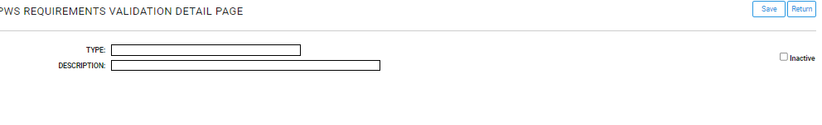
See the General Navigation section for more details on how to navigate the rest of the table on the main page.
    - Equipment Listing
This lists and defines equipment associated with quality, including the details against each equipment including departments, unique IDs, sites, and involved personnel. Admins can add records by selecting Add Equipment in the righthand upper corner of the page. From there, provide the required fields (fields with asterisks) and select Save once filled in.
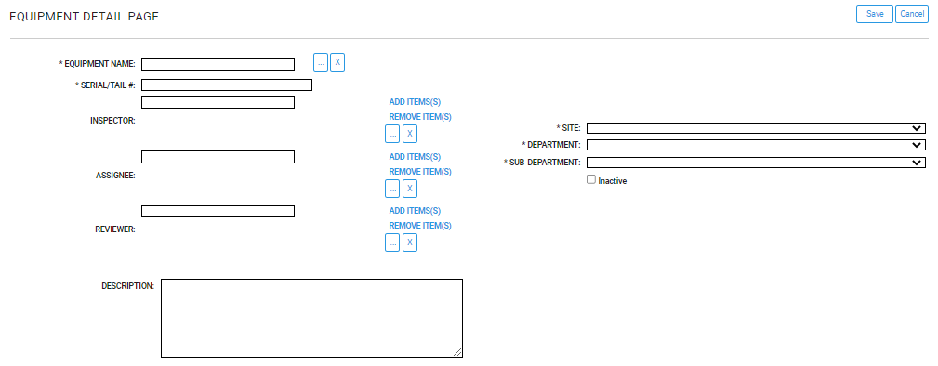
See the General Navigation section for more details on how to navigate the rest of the table on the main page.
    - Area Listing
This page provides the list of areas associated with quality, including the details against each equipment including departments, unique IDs, sites, and involved personnel. Admins can add records by selecting Add Area in the righthand upper corner of the page. From there, provide the required fields (fields with asterisks) and select Save once filled in.
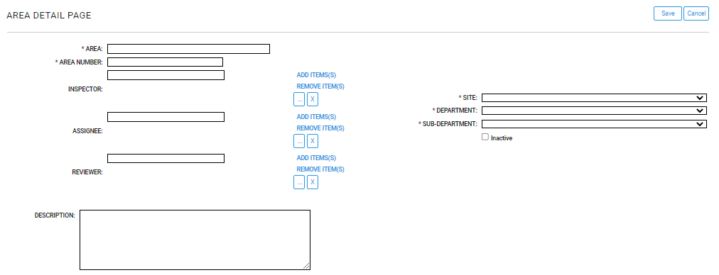
See the General Navigation section for more details on how to navigate the rest of the table on the main page.

    - Contract Setup
This page provides the ability to Synchronize Schedules and Synchronize Findings. For synchronizing schedules, this processes all masters to synchronize and create schedules. For synchronizing findings, it synchronizes workflow definitions for all findings. When the synchronization is successful for either job, it will say SYNCHRONIZE SUCCEEDED AT: and will print the time it succeeded.
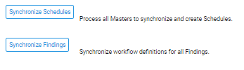

Risk Module
All admin capabilities under this module can be found under the Risk Admin dropdown.
    - Risk Admin Impact
This shows the level of risk impact defined by name and value. For example, the value of 1 can have the name Super Low and the value of 5 can have the name Super High; the other numbers in between would represent a more moderate name compared to the other two. These can be customized up to 50 characters and can be saved by selecting the Save button in the righthand upper corner of the page.
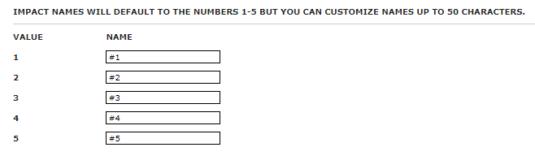
    - Risk Admin Probability
This shows the level of risk probability defined by name and value. For example, the value of 1 can have the name Super Low and the value of 5 can have the name Super High; the other numbers in between would represent a more moderate name compared to the other two. These can be customized up to 50 characters and can be saved by selecting the Save button in the righthand upper corner of the page.
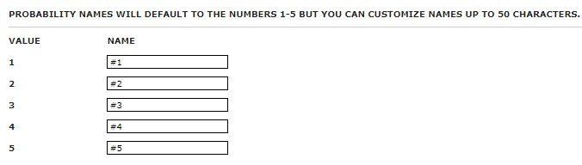

ROM Module
All admin capabilities under this module can be found under the Admin dropdown.
    - Setup
This location helps with contract setup, specifically the form settings. These setting include Use ODC Fee and Hide Default Totals. Definitions are on each side of the form settings listed and by selecting Save in the righthand upper corner, changes can be saved. To activate, admins can check on and off the settings listed.
    - Manage Sites
This page shows the sites that are currently active or inactive along with who they were last updated by and when they were last updated. An admin can add site names by selecting Add New. From there, admins can add information related to a specific site, with definitions of the fields next to the field names. Select Save to save the information.
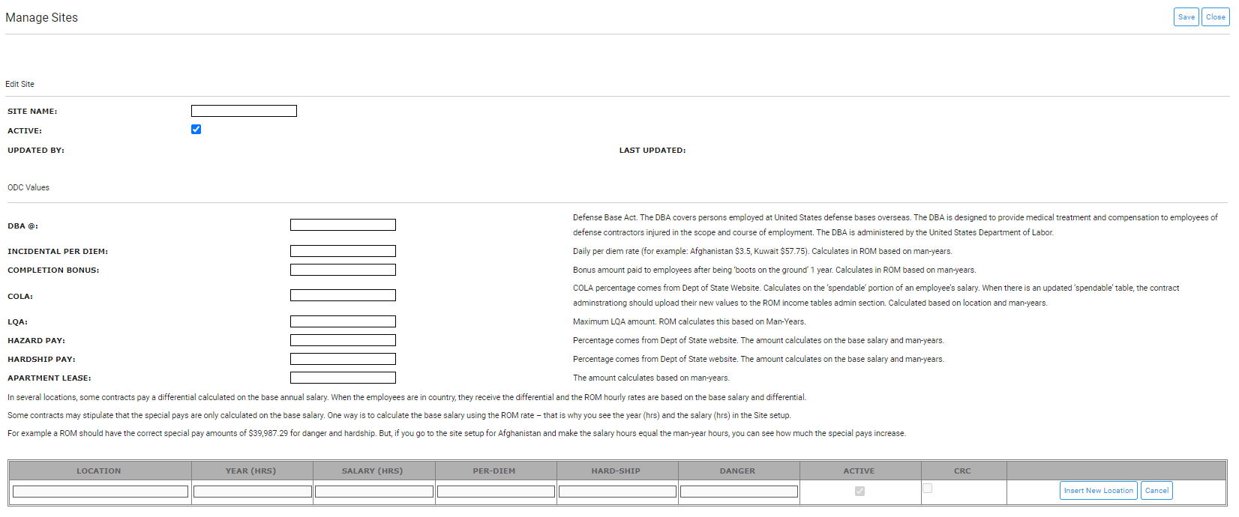
See the General Navigation section for more details on how to navigate the rest of the table on the main page.
    - Manage Labor Categories
This page shows the labor categories that are currently active or inactive along with who they were last updated by, the base rate, the labor code, and when they were last updated. An admin can add new labor categories by selecting Add New. Fill out the information reflected in the below screenshot and select Save once completed.
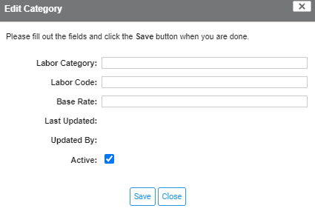
See the General Navigation section for more details on how to navigate the rest of the table on the main page.
    - Manage CTN Drop-Downs
This provides the CTN dropdowns including the CTN name, last updated, updated by, and active status. See the General Navigation section for more details on how to navigate the rest of the table on the main page.
    - Manage Subcontractors
This defines sub-contractors associated with ROMs including the sub-contractor name, code, base rate, and active status. Admins can create a new sub-contractor by selecting Add New in the left-hand side of the page. Fill out the information reflected in the below screenshot and select Save once completed.

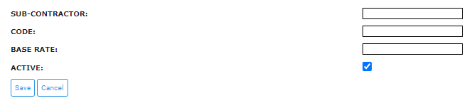
See the General Navigation section for more details on how to navigate the rest of the table on the main page.
    - Manage Income Table
This page defines the spendable income, in which it defines base salary, family member counts, and averages. Admins can add new records by selecting Add New in the left-hand upper corner of the page. Fill out the information reflected in the below screenshot and select Save once completed.
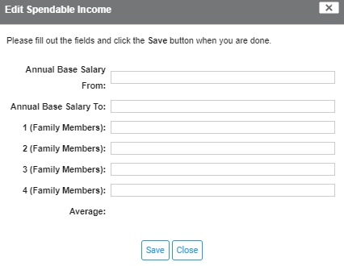
See the General Navigation section for more details on how to navigate the rest of the table on the main page.
    - Manage Section Templates
This page defines the section templates along with their sort order, if they are locked, and if they are active. Admins can Select a section to manage by using the drop-down in the left-hand upper corner and selecting Go once a section is selected.
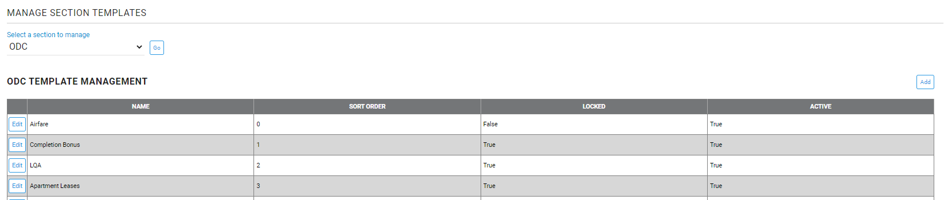
Admins can add new records by selecting Add in the right-hand upper corner of the page. In the form, provide the name, select the sort order number, determine if the form’s edits should be locked or not, and select if it should be active. Select Save once finished.
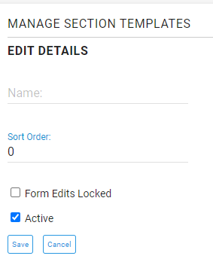
See the General Navigation section for more details on how to navigate the rest of the table on the main page.

Survey Module
All admin capabilities under this module can be found under the Admin dropdown.
    - Manage Sites
This page shows the sites that are currently active or inactive. An admin can create a survey by selecting Create Survey. Admins should fill out all fields, then Save and Print the Survey/Feedback. 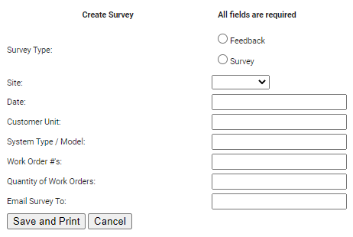
See the General Navigation section for more details on how to navigate the rest of the table on the main page.

Tasking Module
All admin capabilities under this module can be found under the Admin dropdown.
    - Manage Drop-Downs
This page is where admins can manage drop-downs, which can also be done in the Admin module. See the Sites section for more information.
    - Manage Workflow Default Assignments
This page is where admins can view assignments based on selecting a Site and a Role. Once those have been selected, an Admin can click on View to see the current users.
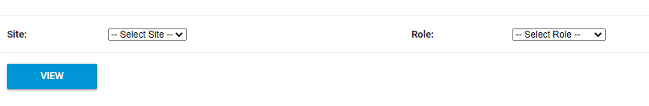
Admins can remove users by selecting one or multiple users and clicking Remove, or add users by selecting users in the drop-down under Assign Users and selecting Add when done.

Training Module
All admin capabilities under this module can be found under the Course Admin and Class Admin dropdown.
    - Course Admin
One of the admin dropdowns designated for courses under the Training module.
      - Active Courses
This page is where active courses are shown along with their course number, category, type, frequency, course admin, and active status. Admins can add courses by selecting Add Course at the right-hand upper corner of the screen. Admins should fill out the required fields with red asterisks and select Save once completed.
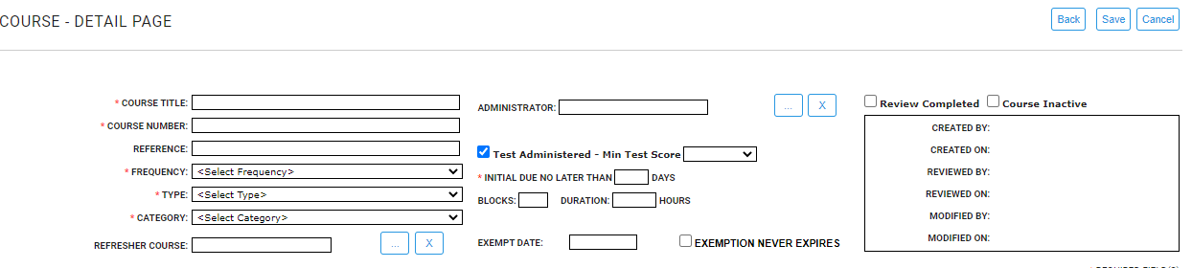
See the General Navigation section for more details on how to navigate the rest of the table on the main page.
      - Inactive Courses
This page is where inactive courses are shown along with their course number, category, type, frequency, course admin, and status. Admins can add courses by selecting Add Course at the right-hand upper corner of the screen with the same information as the Active Courses section. See the General Navigation section for more details on how to navigate the rest of the table on the main page.
      - All Courses
This page is where all courses are shown along with their course number, category, type, frequency, course admin, and status. Admins can add courses by selecting Add Course at the right-hand upper corner of the screen with the same information as the Active Courses section. See the General Navigation section for more details on how to navigate the rest of the table on the main page.
      - Assign Courses By
Job Group: This shows the job groups for course assignments where admins can search and select the job groups. Admins can assign courses to job groups by first clicking on the hyperlink associated with the line-item. Then, select Unassigned Courses to move to the Assigned Courses by clicking on the “>>” arrows in between the Unassigned and Assigned Courses. Admins can unassign courses by doing the opposite actions.
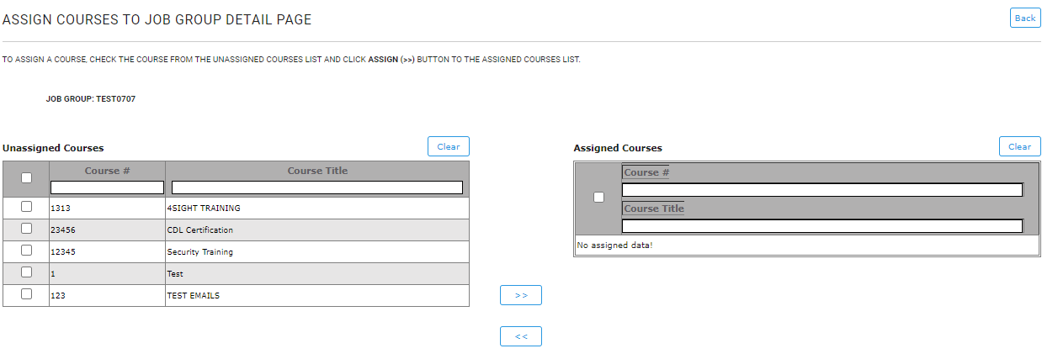
Position: This shows the positions for course assignments where admins can search and select the positions. Admins can assign courses to positions by first clicking on the hyperlink associated with the line-item. Then, select Unassigned Courses to move to the Assigned Courses by clicking on the “>>” arrows in between the Unassigned and Assigned Courses. Admins can unassign courses by doing the opposite actions.
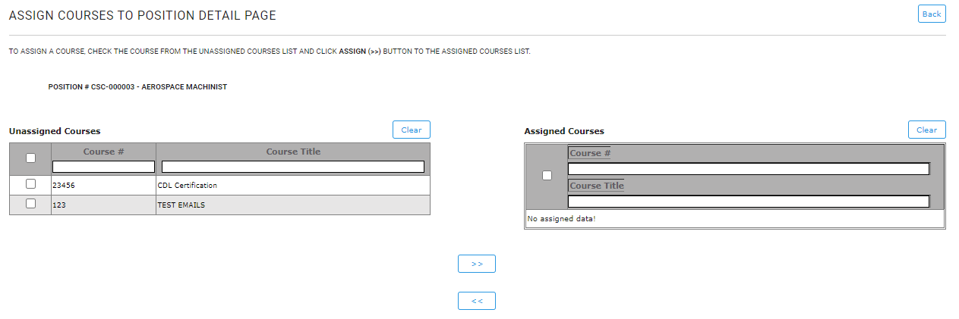
People: This shows the people for course assignments where admins can search and select the people. Admins can assign courses to people by first clicking on the hyperlink associated with the line-item. Then, select Unassigned Courses to move to the Assigned Courses by clicking on the right two arrows in between the Unassigned and Assigned Courses. Admins can unassign courses by doing the opposite actions.
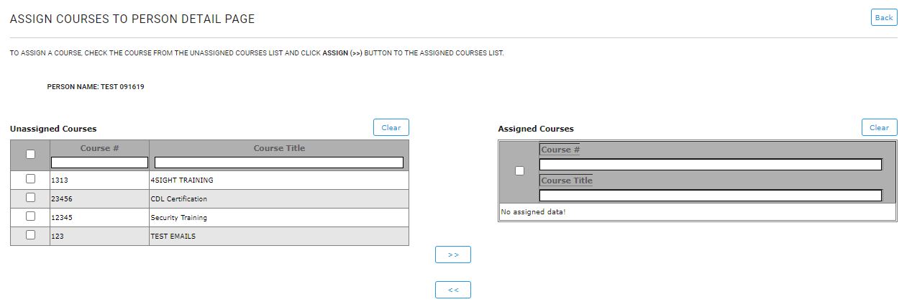

    - Class Admin
One of the admin dropdowns designated for classes under the Training module.

4.9.2.1 Active Classes
This page shows active classes associated with courses, with the ability to expand courses and see associated classes, search for courses, and add classes. Admins can add classes to courses by first clicking on Add Class on the line-item. Then, they can add details regarding class info, view the class roster, and class sign-off. They can also see the history trail of the information.
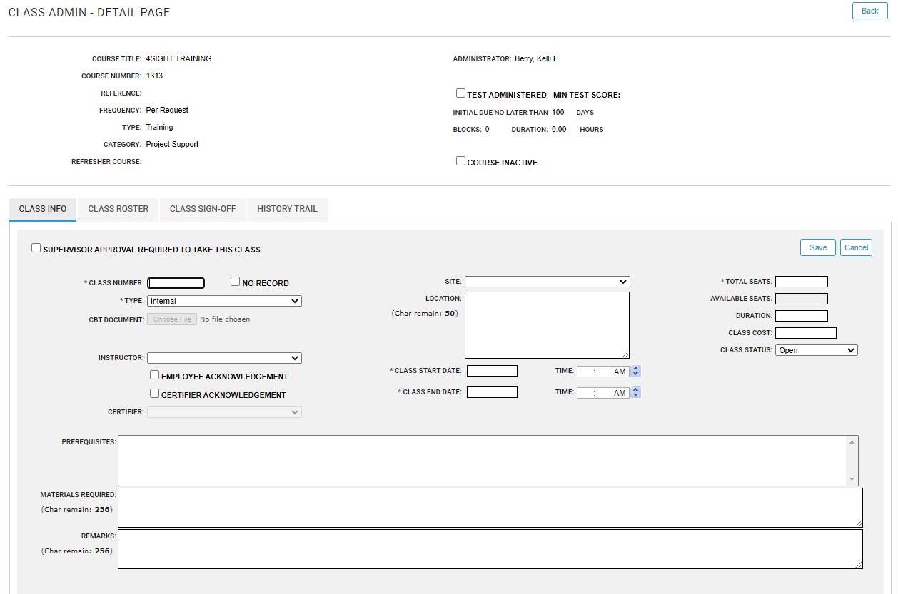
Back on the main page, admins can edit classes by expanding the course on the main active classes page.
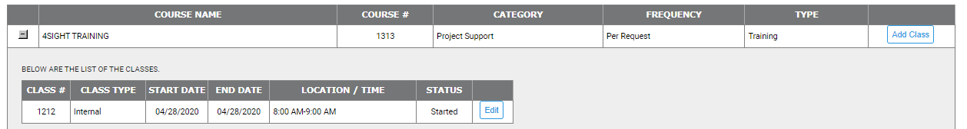
Then, selecting the class by selecting Edit on the line item. Visit the General Navigation section for more information on Advanced Search capabilities on the main page.
      - Closed Classes (For Last 12 Months)
This page shows closed classes associated with courses, with the ability to expand courses and see associated classes, search for courses, and add classes. Follow the instructions from the Active Classes section for more information on how to navigate similar sections. Visit the General Navigation section for more information on Advanced Search capabilities on the main page.
      - Archive Classes
This page shows archived classes associated with courses, with the ability to expand courses and see associated classes, search for courses, and add classes. Admins can re-open classes to courses by first clicking on the hyperlinked class number on the line-item. Then, they can view details regarding the archived class and select Re-Open in the below the tabbed information.
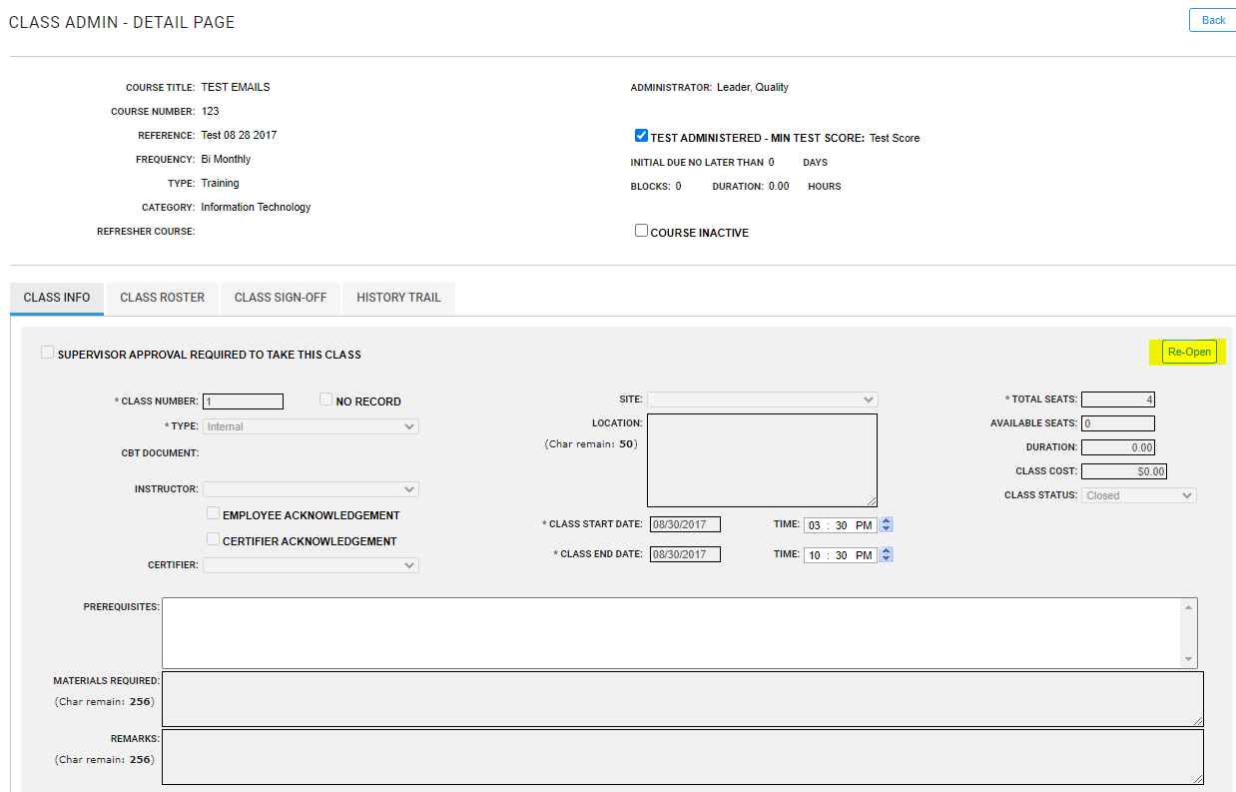
Follow the instructions from the Active Classes section for more information on how to navigate similar sections. Visit the General Navigation section for more information on Advanced Search capabilities on the main page.

Transportation Module
All admin capabilities under this module can be found under the Admin dropdown.

4.10.1 Settings
This location provides admin settings for shipping coordinators, statements on shipments, and instructions on imports. Admins can select or remove shipping coordinators by using the Add Item(s) button or the Remove Item(s) button.
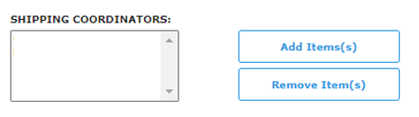
For the statements and instructions portion of the page, admins can add text to the boxes where applicable and select Save at the bottom of the page.
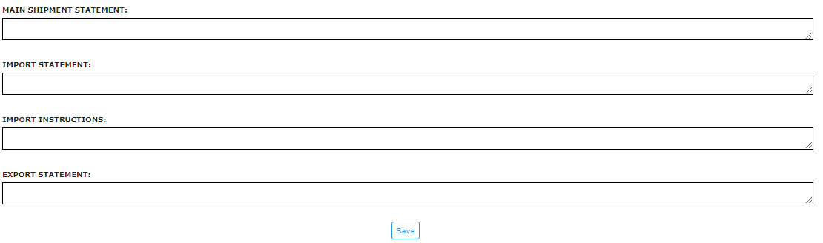

4.10.2 Manage Drop-Downs
This page provides a place to setup drop-down values. Admins can select the blue boxes provided to view values and active statuses related to the selection.
To add values, admins can select the Add button on the left-hand side of the page. Admins can then fill out the necessary information including the Value field, then select Save.
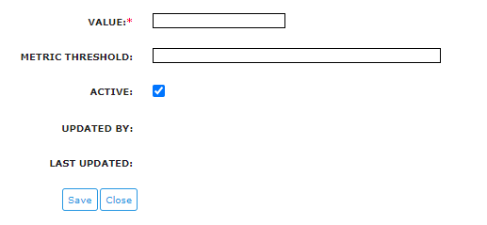
Visit the General Navigation section for more information on capabilities on the main page.
    - Manage Sites
This page shows sites with their related descriptions and active statuses. Admins can add new sites by selecting Add on the left-hand upper corner, then filling out the Site Name, necessary information, and contact information, and then selecting Save.
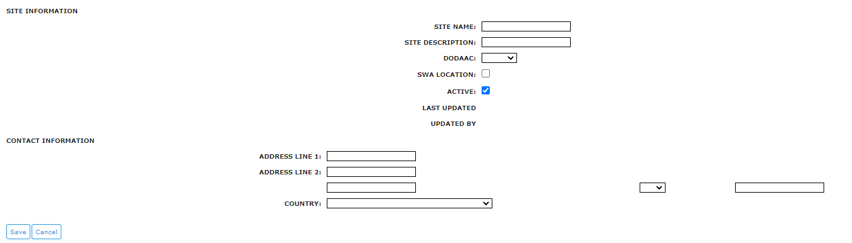
Visit the General Navigation section for more information on capabilities on the main page.

4.10.4 Manage Receiving POCs
This page shows receiving POCs with their related details and active statuses. Admins can add new receiving POCs by selecting Add New on the left-hand upper corner. Fill out the information and Save the record.
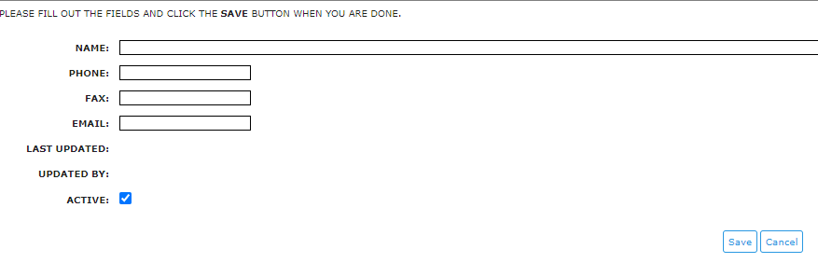
Visit the General Navigation section for more information on capabilities on the main page.
    - Manage Shipping POCs
This page shows shipping POCs with their related details and active statuses. Follow the instructions from the Manage Receiving POCs section for adding new records. Visit the General Navigation section for more information on capabilities on the main page.
    - Manage Modes of Shipment
This page shows modes of shipment with their related details and active statuses. Admins can add new modes of shipment by selecting Add on the left-hand upper corner. Fill out the information including the required field Mode of Shipment, and select Save once completed.
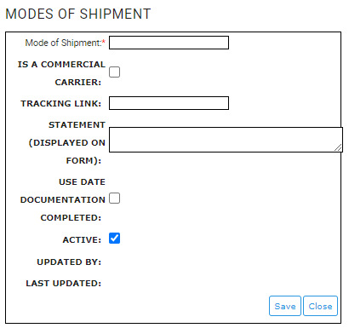
Visit the General Navigation section for more information on capabilities on the main page.
    - Manage RMA Types
This page shows RMA types with their related details and active statuses. RMA Types are the values populated in the RMA drop-down on the shipment form. Admins can add new RMA types by selecting Add on the left-hand upper corner. Fill out the information including the required field RMA Type, and select Save once completed.
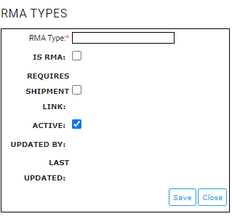
Visit the General Navigation section for more information on capabilities on the main page.
    - Manage Approvers
This provides default approvers for the module. This includes transportation admin, editor, PMO, trade and compliance, and empowered official. Multiple individuals can be added or removed by using Add Item(s) or Remove Item(s) on the righthand side of each approver role. Admins can select the Limit To Current Contract box to limit the user selection to the current contract only so that they select all users in the contract and add them at once. Admins can select Save once changes have been made.
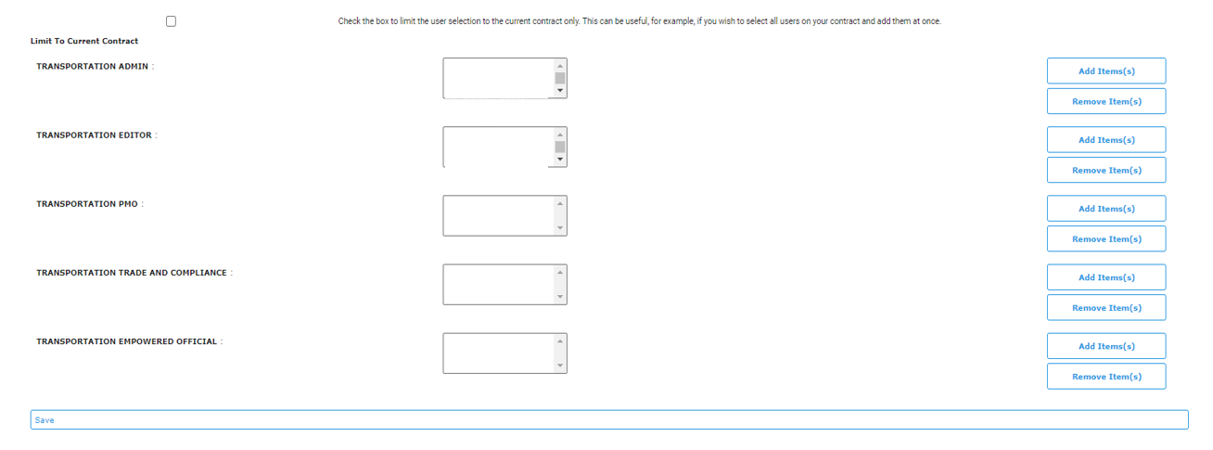

Travel Module
All admin capabilities under this module can be found under the Admin dropdown.

4.11.1 Admin Setup
This gives you the ability to setup the contract information for the program. Filling this out applies to the program as a whole including its name, client, contractor, task order, and CECOM forward-deployed TPOC. Add or Remove Items by selecting the two blue links on the righthand side of the page. Save the information by selecting Save.
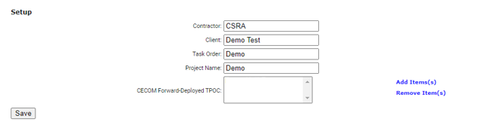
    - Manage Drop-Downs
This page allows admins to edit site and company dropdowns. By selecting Edit Sites in blue, you can see all sites associated with the program.
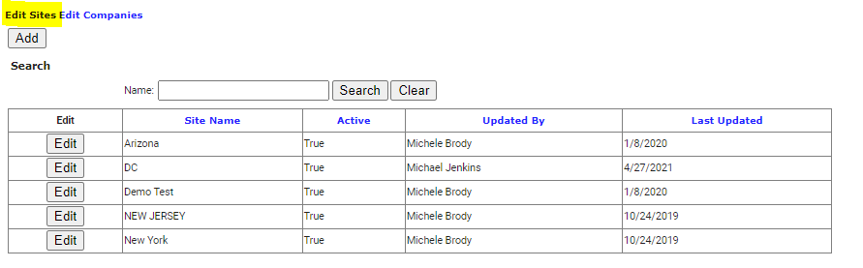
By selecting Edit Companies in blue, you can see all companies associated with the program.
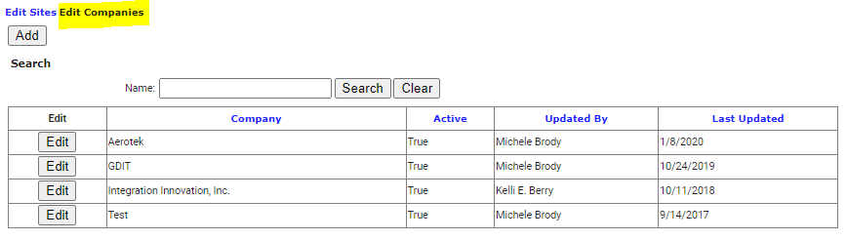
Both links show the names of the information, if it is active, when it was last updated, and who updated the item. By selecting Add under the Edit Sites and Edit Companies, admins can add the necessary information. Admins can also edit the entries by selecting Edit next to the desired entry. There is also a Search capability to find a specific record.
    - Contract Funding
This is a view of the funding available in the current module. Visit the General Navigation section for more information on capabilities on the main page. Funding can be imported in bulk through the Admin module.

Additional Information

General Navigation
Most pages within the Admin module and other modules with admin capabilities do have similar navigation and views. This section supports general page navigation that can be found on multiple admin pages.
- Edit Details – Generally the tables within 4Sight have a similar setup for admins: the description, its status, and if you would like to edit such details. Depending on the table, editing details can be done with the Edit Details button, the Edit button, or selecting a hyperlink in the first column of the table. At times, there may be multiple other columns regarding individual records. However, most table functions work the same unless stated otherwise in the document. Below is an example of records that require admins to click Edit Details next to the line item:
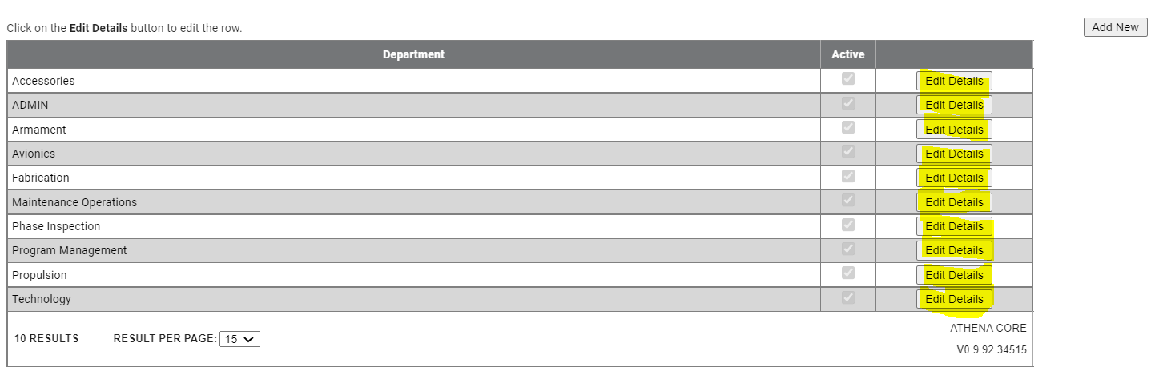
Below is an example of records that require admins to click on the blue hyperlink in the first column to edit details:
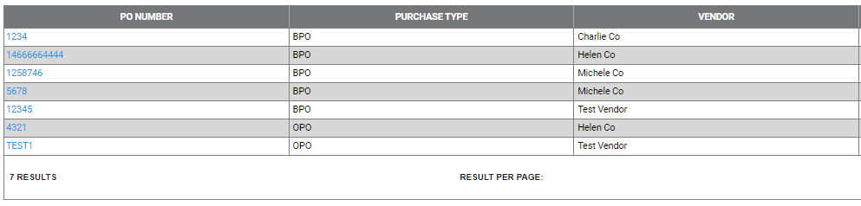
Below is an example of records that require admins to click Edit in the first column to edit details:
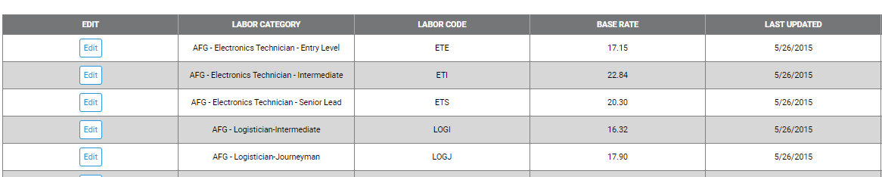
- Add New Records – Selecting in the top corner of most pages can show different new record forms that can have required and optional fields. The red or black asterisks on certain fields in the forms represent required fields. Most forms have dropdowns, checkboxes, and boxes to fill in information. Selecting the Save button after completing the new record is how the new record is added to the list of current records. An example of the new record form can be found below:
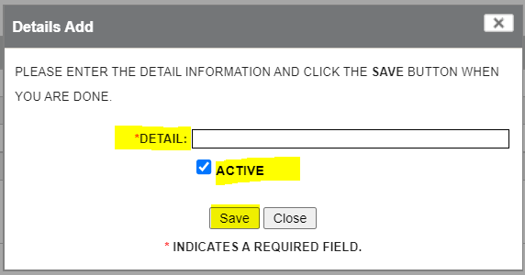
- Show Search/Advanced Search Capabilities – Depending on the table and number of records, selecting Show Search can show an Advanced Search capability where users can narrow the records down in a table by filtering on desired information based on fields. Users can search on specific information by filling out the desired information and selecting Search. To remove any text in the search boxes, users can select Clear in order to start over with a blank canvas for the search. Users can save this information by selecting Save Criteria in order to save their selected search filters. The Hide button simply hides the advanced search.
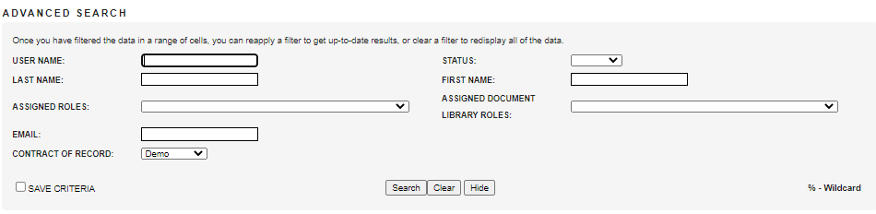
- Export To Function – Gives users the ability to export the information in a table to a PDF, XLS, or CSV.
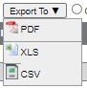
- Pages – To go through pages of a table, simply go to the bottom of the table and select the right arrow or left arrow to navigate. Additionally, you can change the number of results per page by selecting the dropdown option for Result Per Page. A user can also go to a specific page by typing in the number on the Go To Page box and selecting Go. See the below screenshot of the fields mentioned:

Communications to 4Sight Admins
5.2.1 Escalating to 4Sight Admins
4Sight Admins have the 4Sight-Developer role as well as all roles/rights within 4Sight and across programs using 4Sight. Contract Admins should escalate the following issues to 4Sight Admins:
- Bugs/small issues with 4Sight
- Immediate changes needed, such as additional existing fields to a table
- 4Sight outages (when the application is throwing an error when on the welcome page)
- Broken links to pages
- Locked out of 4Sight account
5.2.2 Notifications from Optasia
Optasia (optasia@4Sightpm-us.com) is the account used for global communications to all 4Sight users. Announcements such as outages, password changes, scheduled maintenance, sprint releases, and other important communications will be provided from this email. Contract admins should look out for information from this account on any issues or important announcements that may affect their day-to-day work in 4Sight.

Requesting Admin Access
To get admin access, provide the user’s name, the username, and the email to the 4Sight Support Address or to the associated program’s contract admin.

Acronyms/Terms
Name | Meaning
Admin | Administrator
AFSB | Army Field Support Battalion
AssetNo | Asset Number
CECOM | Communications-Electronics Command
CLIN | Contract Line Item Number
CTN | Customer Tracking Number
GCSS | Global Combat Support System
GFE | Government Furnished Equipment
GIT | Global Information Tracker
ID | Identification
ISO | International Organization for Standardization
LOA | Letter of Authorization
ODC | Other Direct Charges
PMC | Project Management Contract
PMO | Program Management Office
PO | Purchase Order
POC | Point of Contact
PR | Purchase Request
PWS | Performance Work Statement
RMA | Return Merchandise Authorization
ROM | Rough Order of Magnitude
SLIN | Sub-Contract Line Item Number
SWA | Southwest Asia
TAR | Travel Authorization Request
TBD | To Be Determined
TPOC | Technical Point of Contact
WD | Wage Determinations

